Cabbage Extract Synthesis
Date: March 14, 2024 | Researchers Involved: Cheng Roa, Lopez, Evora

Cycle Count | 20% (50g Cabbage) | 40% (100g Cabbage) | 60% (150g Cabbage)
1 | Extract Time: 45 s  Extract Temp: 30°C  Time Mix: 1:15 s | Extract Time: 45 s  Extract Temp: 28°C  Time Mix: 1:30 s | Extract Time: 45 s  Extract Temp: 33°C  Time Mix: 1:30 s
2 | Extract Time: 45 s  Extract Temp: 40°C  Time Mix: 1:15 s | Extract Time: 45 s  Extract Temp: 39°C  Time Mix: 1:15 s | Extract Time: 45 s  Extract Temp: 61°C  Time Mix: 2:30 s
3 | Extract Time: 45 s  Extract Temp: 50°C  Time Mix: 1:15 s | Extract Time: 45 s  Extract Temp: 53°C  Time Mix: 1:15 s | Extract Time: 45 s  Extract Temp: 74°C  Time Mix: 2:30 s
4 | Extract Time: 45 s  Extract Temp: 60°C  Time Mix: 1:15 s | Extract Time: 45 s  Extract Temp: 58°C  Time Mix: 1:15 s | Extract Time: 45 s  Extract Temp: 76°C  Time Mix: 2:30 s
5 | Extract Time: 45 s  Extract Temp: 65°C  Time Mix: 1:15 s | Extract Time: 45 s  Extract Temp: 62°C  Time Mix: 1:15 s | Extract Time: 45 s  Extract Temp: 74°C  Time Mix: 2:30 s
6 | Extract Time: 45 s  Extract Temp: 70°C  Time Mix: 1:15 s | Extract Time: 45 s  Extract Temp: 68°C  Time Mix: 1:15 s | Extract Time: 45 s  Extract Temp: 78°C  Time Mix: 2:30 s
7 | Extract Time: 45 s  Extract Temp: 74°C  Time Mix: 1:15 s | Extract Time: 45 s  Extract Temp: 73°C  Time Mix: 1:15 s

Cabbage Extract Phytochemical Tests
Date: March 18, 2024 | Researchers Involved: Cheng Roa, Lopez, Relayo, Evora

Extracts | Alkaline Reagent Test | Shinoda Test
20% (50g Cabbage) | P | F
40% (100g Cabbage) | P | F
60% (150g Cabbage) | P | F

Cabbage Extract Observation
Day: 0 (March 19) | Researchers Involved: Cheng Roa, Evora, Relayo, Lopez

Control 1 | T1-1 | T2-1 | T3-1
1 – 105.5 g  2 – 105.0 g  3 – 107.0 g  4 – 121.0 g | 1 – 118.5 g  2 – 115.5 g  3 – 107.5 g  4 – 112.0 g | 1 – 121.5 g  2 – 107.0 g  3 – 129.0 g  4 – 127.5 g | 1 – 110.0 g  2 – 128.5 g  3 – 113.0 g  4 – 130.5 g
Control 2 | T1-2 | T2-2 | T3-2
1 – 88.0 g  2 – 112.0 g  3 – 139.5 g  4 – 117.0 g | 1 – 104.5 g  2 – 97.5 g  3 – 104.0 g  4 – 106.5 g | 1 – 137.5 g  2 – 131.0 g  3 – 131.0 g  4 – 133.5 g | 1 – 85.5 g  2 – 97.5 g  3 – 99.5 g  4 – 111.5 g
Control 3 | T1-3 | T2-3 | T3-3
1 – 146.0 g  2 – 112.0 g  3 – 139.5 g  4 – 170.0 g | 1 – 147.0 g  2 – 152.0 g  3 – 132.5 g  4 – 137.0 g | 1 – 124.5 g  2 – 130.0 g  3 – 127.5 g  4 – 134.5 g | 1 – 168.0 g  2 – 145.5 g  3 – 140.5 g  4 – 155.5 g
Control 4 | T1-4 | T2-4 | T3-4
1 – 236.0 g – 3x10⁶ Pa  2 – 301.5 g – 3x10⁵ Pa  3 – 232.0 g – 3.5x10⁵ Pa  4 – 230.5 g – 3.7x10⁵ Pa | 1 – 189.5 g – 3.5x10⁶ Pa  2 – 219.0 g – 3x10⁵ Pa  3 – 191.5 g – 3.2x10⁶ Pa  4 – 141.5 g – 3.4x10⁶Pa | 1 – 153.0 g – 3.8x10⁶ Pa  2 – 176.5 g – 4.8x10⁵ Pa  3 – 199.5 g – 4.8x10⁵ Pa  4 – 187.5 g – 3.5x10⁵ Pa | 1 – 195.5 g – 4.8x10⁵ Pa  2 – 305.5 g – 4x10⁵ Pa  3 – 170.0 g – 4.3x10⁵ Pa  4 – 264.0 g – 4.8x10⁵ Pa

Cabbage Extract Observation
Day: 7 (March 26) | Researchers Involved: Cheng Roa, Relayo, Lopez, Evora

Control 1 | T1-1 | T2-1 | T3-1
1 –  2 –  3 – 74.5 g  4 – 80.0 g | 1 – 85.0 g  2 –  3 – 82.5 g  4 – 83.5 g | 1 – 92.0 g  2 – 79.5 g  3 – 95.0 g  4 – 92.5 g | 1 – 87.0 g  2 – 99.5 g  3 –  4 – 87.5 g
Control 2 | T1-2 | T2-2 | T3-2
1 – 64.0 g  2 – 80.5 g  3 –  4 – 74.5 g | 1 –  2 –  3 – 73.5 g  4 – 73.0 g | 1 – 76.0 g  2 –  3 – 84.0 g  4 – | 1 – 70.0 g  2 – 63.5 g  3 – 72.5 g  4 – 84.0 g
Control 3 | T1-3 | T2-3 | T3-3
1 – 132.5 g  2 –  3 – 115.5 g  4 – 132.0 g | 1 – 106.5 g  2 – 123.0 g  3 –  4 – 98.5 g | 1 – 87.0 g  2 –  3 –  4 – 98.5 g | 1 –  2 –  3 – 97.5 g  4 –
Control (Penetrometer) | T1 (Penetrometer) | T2 (Penetrometer) | T3 (Penetrometer)
C1, 4 – 2.5 x10⁵ Pa  C2, 2 – 2.6 x10⁵ Pa  C3, 4 – 1.7 x10⁵ Pa  C3. 1 – 2.8 x10⁵ Pa  C2-4 – 2.3 x10⁵ Pa | T1-1, 1 – 3.1 x10⁵ Pa  T1-1, 2 – 2.9 x10⁵ Pa  T1-1, 3 – 3 x10⁵ Pa  T1-1, 4 – 2.5 x10⁵ Pa  T1-2, 3 – 2.6 x10⁵ Pa  T1-2, 4 – 2.3 x10⁵ Pa  T1-3, 1 – 2.9 x10⁵ Pa  T1-3, 2 – 2.8 x10⁵ Pa | T2-1, 1 – 2.4 x10⁵ Pa  T2-1, 2 – 2.8 x10⁵ Pa  T2-1, 3 – 2.5 x10⁵ Pa  T2-1, 4 – 2.9 x10⁵ Pa  T2-2, 1 – 1.9 x10⁵ Pa  T2-2, 3 – 2 x10⁵ Pa  T2-3, 1 – 2.3 x10⁵ Pa  T2-3, 4 – 2.2 x10⁵ Pa | T3-1, 1 – 2.5 x10⁵ Pa  T3-1, 3 – 2.4 x10⁵ Pa  T3-1, 4 – 2.4 x10⁵ Pa  T3-2, 1 – 2.6 x10⁵ Pa  T3-2, 2 – 2.5 x10⁵ Pa  T3-2, 3 – 3.4 x10⁵ Pa  T3-2, 4 – 2.6 x10⁵ Pa  T3-3, 3 – 2.6 x10⁵ Pa

Cabbage Extract Observation (Signs of Decay)
Day: 0-7 | Researchers Involved: Cheng Roa, Relayo, Lopez, Evora

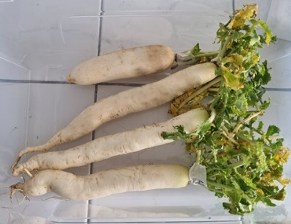
Day 0 (Control 3)
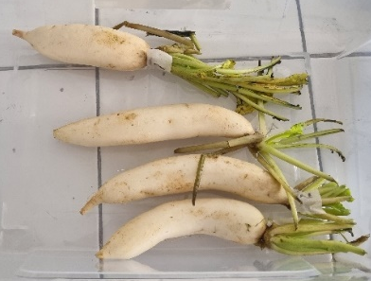
Day 0 (Treatment 1-1)
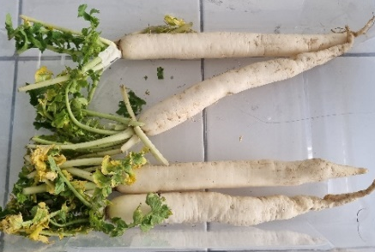
Day 0 (Treatment 2-2)
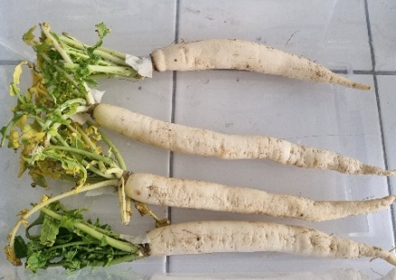
Day 0 (Treatment 3-2)
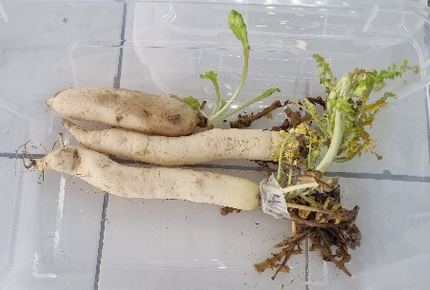
Day 7 (Control 3)
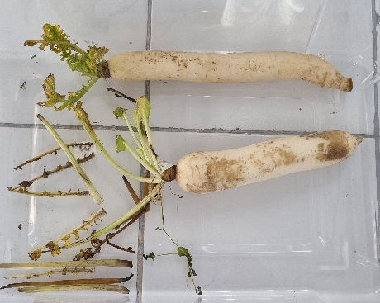
Day 7 (Treatment 1-2)
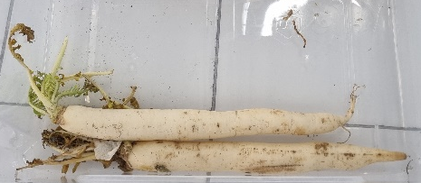
Day 7 (Treatment 2-2)
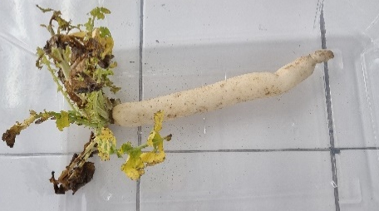
Day 7 (Treatment 3-3)

One-Way ANOVA Computations and Results
Weight Loss & Firmness | Researchers Involved: Cheng Roa

